

App gateway support for web app authentication

Threat Model

Version: v1
Date: 2023-09-25
Email: security@wso2.com

Table of Contents

Revision History 3
Introduction 4
Deployment Architecture 4
Component Architecture 4
Data Flow Diagrams 4
Interactions [01]: Config resolution 5
Interactions [02]: Login 7
Interactions [03]: Logout 8
Interactions [04]: Protected API call 9
Interactions [05]: Userinfo API call 10
Interactions [06]: Token Refresh API call 11
Resources and Assets 11
Interactions 13
Ingress Interactions 13
Untrust to Trust 13
Trust to Trust 13
Egress Interactions 13
Trust to Untrust 13
Trust to Trust 14
Internal Interactions 14
Access Control 16
Threats and Mitigations 19
Resource-level security control 19
Inherited Risks 19
Application-level security vulnerabilities 19
Interactions 22
Interactions [01]: Config resolution (Common to Login, Logout, Token Refresh) 22
Interactions [02]: Login 26
Interactions [03]: Logout 29
Interactions [04]: Protected API call 31
STRIDE 33
Interactions [05]: Userinfo API call 34
STRIDE 35
Interactions [06]: Token Refresh API call 36
STRIDE 38
Interactions [ID]: [Interaction Name] 39
STRIDE 40
References 42
Appendix 43

Revision History

Version | Release Date | Contributors / Authors | Summary of Changes
v1 | 2023-10-19 | Thumula PereraSenthalan Kanagalingam | Initial version

Introduction

Deployment Architecture
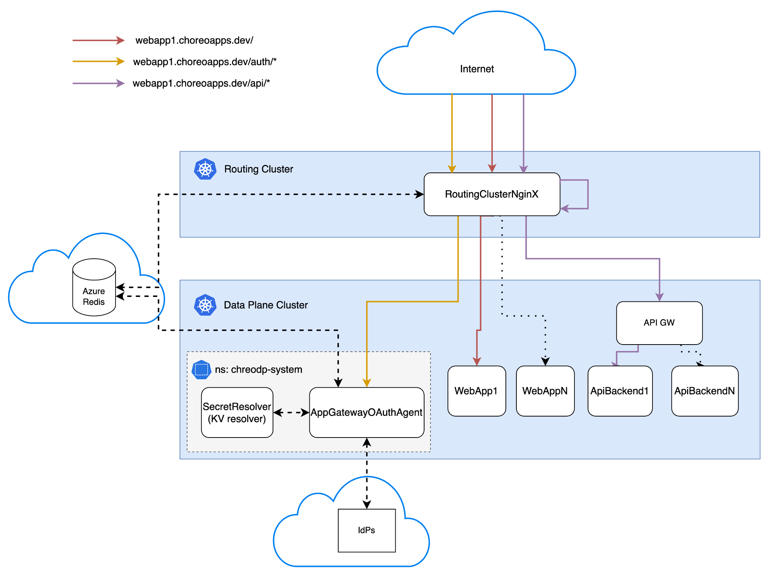

Ref: Design outline

Data Flow Diagrams
DFD Notations
Boundary | Interaction Medium | Data Confidentiality
[B-EX-DP] External dependencies | [M-NT] Network interaction | [C-High] Highly confidential
[B-EX-EN] External entity (such as external APIs, IDPs, or systems) | [M-DB] Database interaction | [C-Medium] Medium confidential
[B-EX-CP] External component to the current feature, but code owned by WSO2 | [M-FS] File system interaction | [C-Low] Low confidential
 | [M-IN] Internal interaction
[SAMPLE DFD]

[Data Flow Diagrams and Reference links]

Interactions [01]: Config resolution

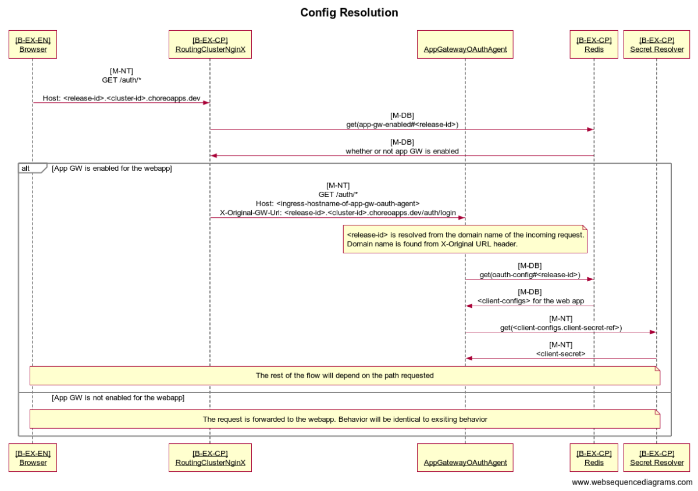

Interactions [02]: Login
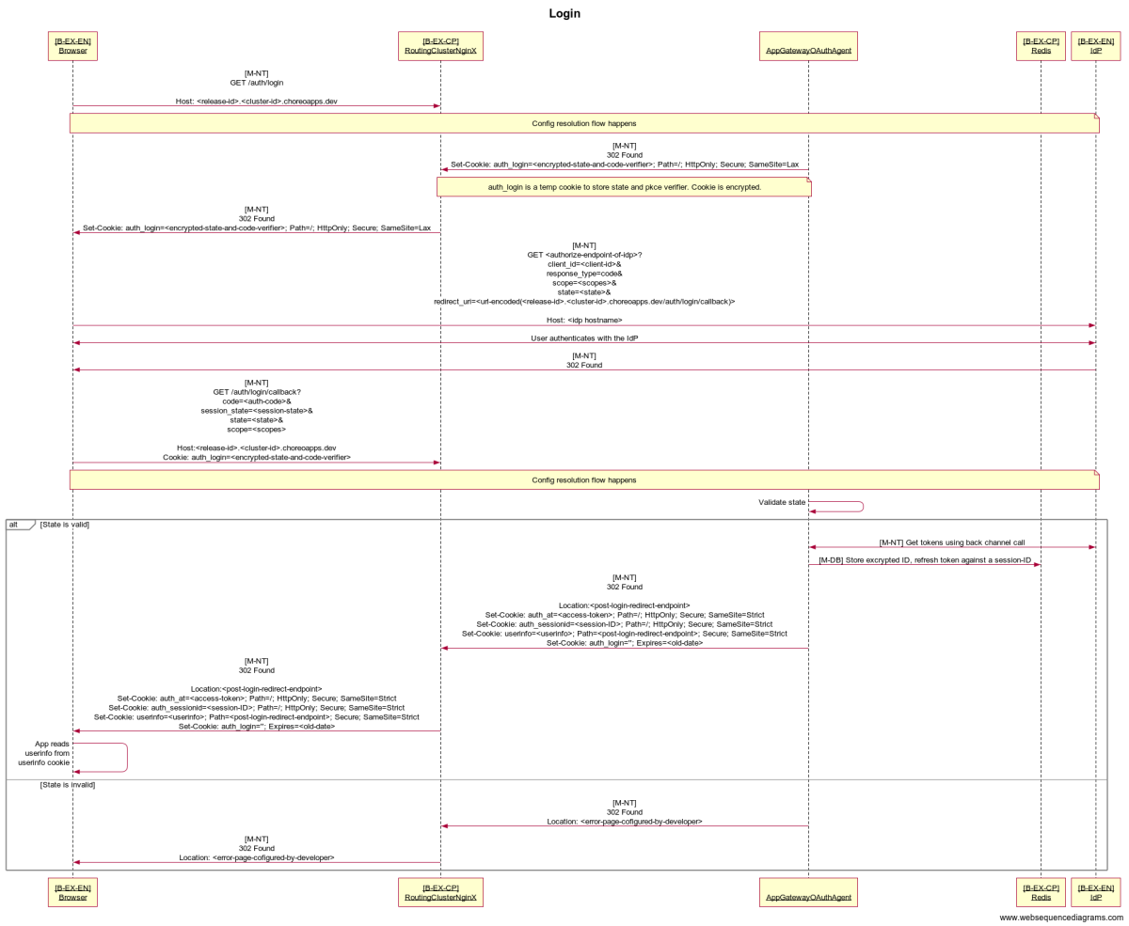

Interactions [03]: Logout
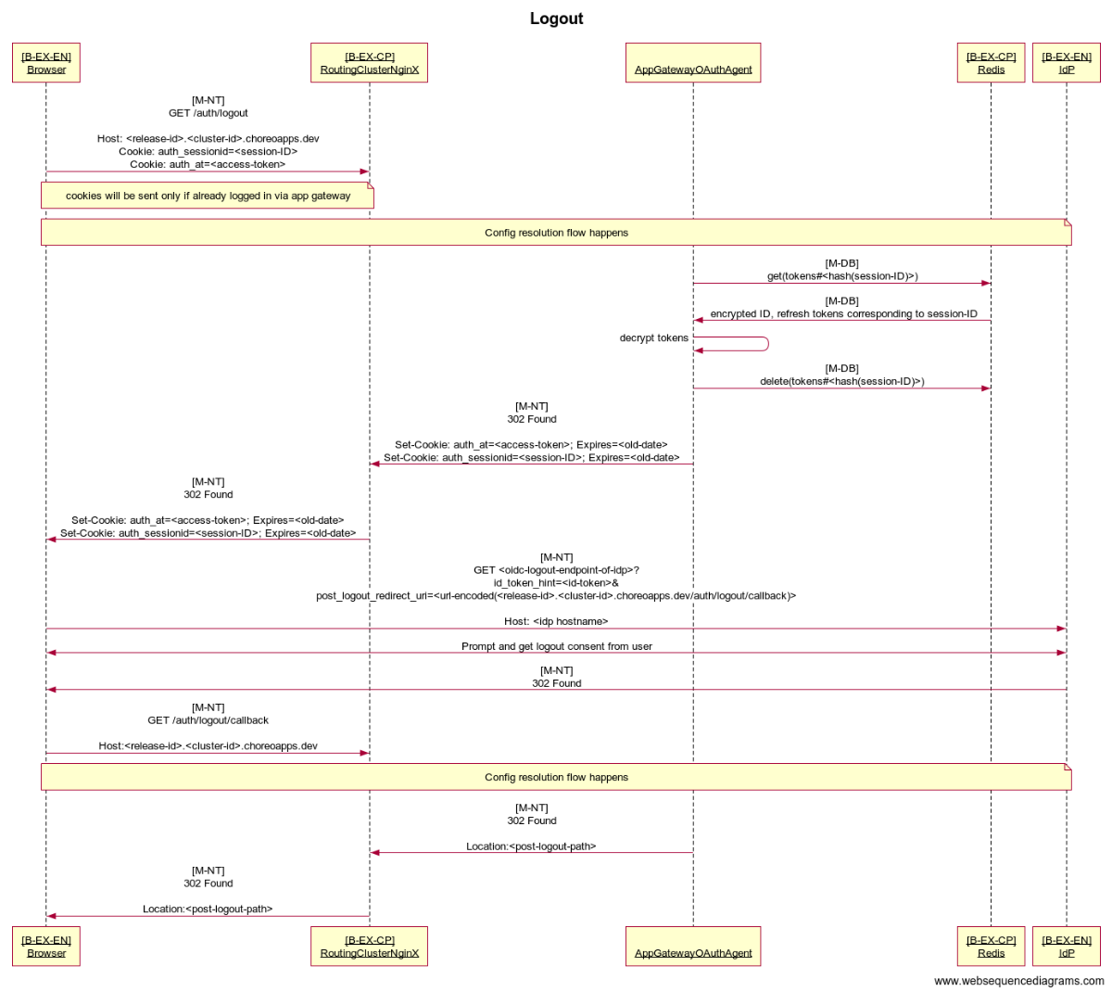

Interactions [04]: Protected API call
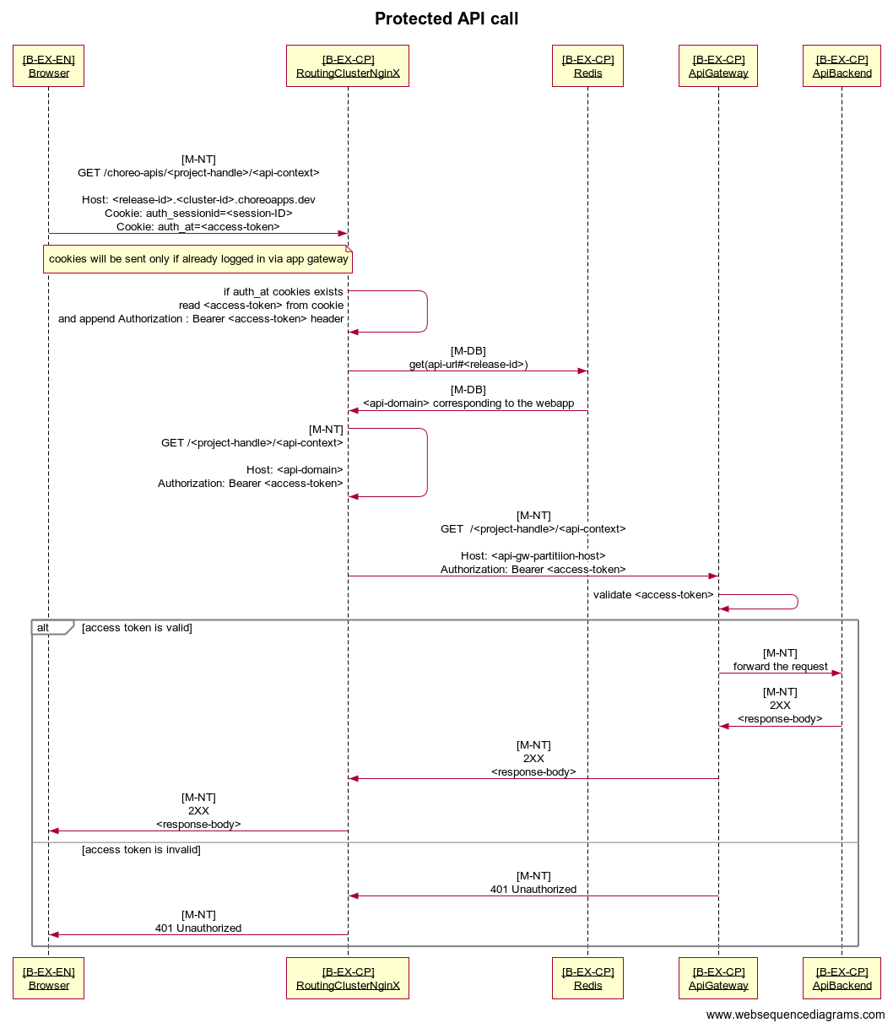

Interactions [05]: Userinfo API call
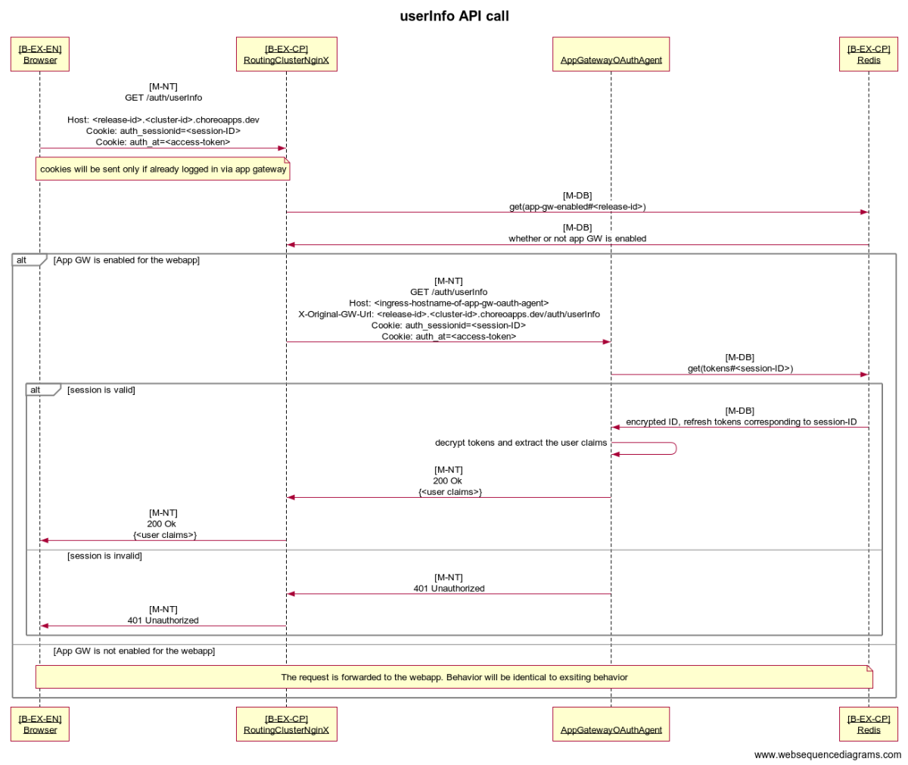

Interactions [06]: Token Refresh API call
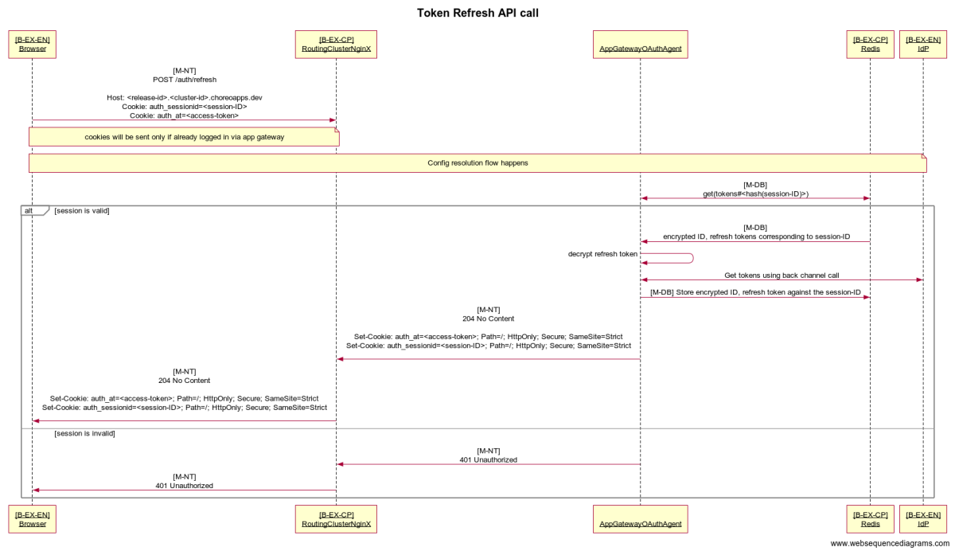

Interactions [07]: Config addition

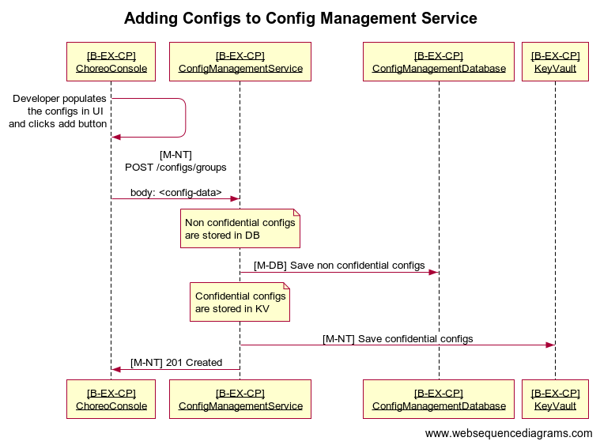

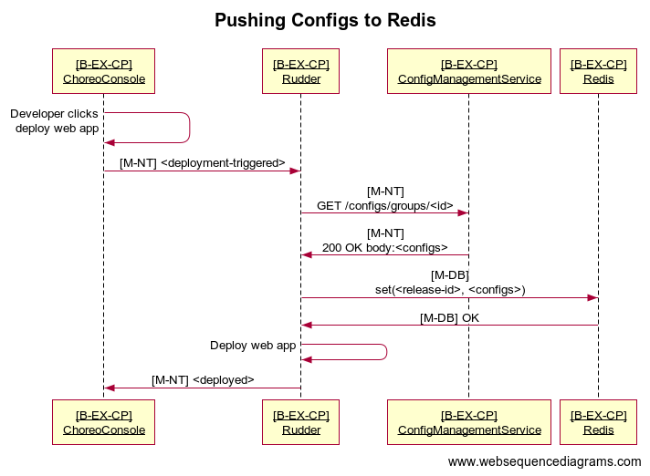

Resources and Assets
This section contains a summarized description of each asset shown in the diagram. The description includes the usage and purpose of the said asset in the deployment.

Assets/Resources
Assets | Description
RoutingClusterNginX | Routes incoming requests as follows  - For requests with /api prefix  - If request contains a cookie auth_at, Append Authorization: Bearer <auth_at_cookie_val> header to the request  - Forward the request to choreo API domain corresponding to the webapp.  - For requests with /auth prefix  - If app gateway is enabled for the web app  - Forward request to AppGatewayOauthAgent  - Else  - Follow existing routing rules  - For any other request, follow existing routing rules
Redis | Stores following information  - isAppGatewayConfigured (Used by NginX)  - Key: is-gw-configured#<release-id>  - Value: “true” | “false”  - API domain corresponding to a webapp (Used by NginX)  - Key: api-url#<release-id>  - Value: string  - Eg: 2d9ec1f6-2f04-4127-974f-0a3b20e97af5-dev.e1-us-east-azure.choreoapis.dev  - App Gateway configurations (Used by AppGatewayOauthAgent)  - Key: proxy-config#<release-id>  - Value: set of key value pairs of all the configs required by AppGatewayOauthAgent  Note that keys are not finalized and might be changed.
AppGatewayOAuthAgent [1] | Handles OIDC, OAuth2 flows on behalf of web apps.  Exposes a set of endpoints [1] used by the web apps to trigger login, logout, token refresh, get userinfo.  On receiving the request, retrieves the set of configs (corresponding to the web app which initiated the request) from Redis. Configs include OAuth2 client configurations, configure IdP endpoints etc.
ApiGateway | Existing choreo API GW.
ApiBackend | A representation of Any API backend deployed in Choreo.
SecretResolver [2] | System component in Data Plane which exposes a REST API to other system components in Data Plane to be used to retrieve secrets from Key Vault.  Used by AppGatewayOAuthAgent to retrieve the client secret corresponding to a given request.
Rudder | Existing Rudder Component (Outside the scope of this threat model)
ConfigManagementSerive | Existing ConfigManagementService Component (Outside the scope of this threat model)

Dependencies
Dependency | Description (usage, purpose, Authentication, and Authorizations, Security)
IdP | Configured per web app by the app developer (meaning, each web app can configure its own IdP). Used as the Authorization Server for OAuth/OIDC flows.  AppGatewayOAuthAgent authenticates with the IdP using client ID, client secret configured for the web app for the request being served.

Interactions

Ingress Interactions

Untrust to Trust
[External untrusted entities initiating communications to deployment, example, Developer accessing Website via Public Internet]
Name | Source | Destination
Initiate login | Internet (User Browser) | AppGatewayOAuthAgent (via RoutingClusterNginX)
Login callback | Internet (User Browser) | AppGatewayOAuthAgent (via RoutingClusterNginX)
Initiate logout | Internet (User Browser) | AppGatewayOAuthAgent (via RoutingClusterNginX)
Logout callback | Internet (User Browser) | AppGatewayOAuthAgent (via RoutingClusterNginX)
Protected API call | Internet (User Browser) | ApiBackend (via RoutingClusterNginX, ApiGateway)
Userinfo API call | Internet (User Browser) | AppGatewayOAuthAgent (via RoutingClusterNginX)
Token Refresh API call | Internet (User Browser) | AppGatewayOAuthAgent (via RoutingClusterNginX)

Trust to Trust
[External Trusted entities initiating communications to deployment, example, Administrator accessing management console of a website VIA VPN connection]
Name | Source | Destination

Egress Interactions

Trust to Untrust
[Invoking communications to External unknown/public entities. example, System invoking covid-19 statistics API]
Name | Source | Destination

Trust to Trust
[Invoking communications to External Trusted entities. example initiating a database connection to customer environment via VPN connection]
Name | Source | Destination
Obtain tokens | AppGatewayOAuthAgent | IDP

Internal Interactions
[Internal interactions, example communicating between components]

Name | Source | Destination
Retrieve NginX related configs | RoutingClusterNginX | Redis
Retrieve configs corresponding to a webapp | AppGatewayOAuthAgent | Redis
Retrieve Client ID | AppGatewayOAuthAgent | SecretResolver

Access Control

N/A

Threats and Mitigations

Interactions

Interactions [01]: Config resolution (Common to Login, Logout, Token Refresh)
Sequence diagram

Assets Involved
Initiator | Intermediate | Target
Web Browser of End User | RoutingClusterNginX, Redis, SecretResolver | AppGatewayOAuthAgent

Description

This is a common scenario for any request that is coming to a path prefixed with /auth. This path is reserved for requests that should go to AppGatewayOAuthAgent and any web app can use the relative path /auth to call endpoints exposed by AppGatewayOAuthAgent.
For any incoming request, AppGatewayOAuthAgent needs to determine the set of configs relevant to the web app to which the request belongs to.

- Browser sends request to <web-app-domain>/auth/*
- RoutingClusterNginX receives the request, sends a request to Redis to check whether app gateway is enabled for the web app
[Note: rest of the description assumes that app gateway is enabled. If not, the behavior would be identical to existing behavior in choreo]
- RoutingClusterNginX appends the header X-Original-GW-Url to the request. The header will contain the original request.
eg: <release-id>.<cluster-id>.choreoapps.dev/auth/login
Note that adding this header is being done currently as well.
- RoutingClusterNginX forwards the request to AppGatewayOAuthAgent.
- AppGatewayOAuthAgent retrieves the configurations specific to the web app from Redis. The key used is proxy-config#<release-id>.
<release-id> is read from the X-Original-GW-Url header.
- Among the configs retrieved from Redis, there will be a reference to the corresponding client secret which is stored in Key Vault. AppGatewayOAuthAgent sends a request to SecretResolver with that reference and retrieves the client secret.

Access Control

Any user on the internet can invoke request to <web-app-domain>/auth/* using a valid <web-app-domain> of a choreo deployed web app which has enabled authentication.
If the path suffix of the request is a valid endpoint exposed by AppGatewayOAuthAgent, the behavior will be as described in the next sections of this document.
If the path suffix of the request is not a valid endpoint exposed by AppGatewayOAuthAgent, a 404 response will be sent.

Security Considerations
Data: OAuth Client Secret of the Web App
Security Considerations | Response
Data Confidentiality | High confidential [C-High]
Communication Medium | Network interaction [M-NT]
Transport Security | TLS Encryption
Authentication | No Authentication
Accessibility | Internal Service Accessible

Data: Other configs of the Web App
Security Considerations | Response
Data Confidentiality | Low confidential [C-Low]
Communication Medium | Network interaction [M-NT]
Transport Security | TLS Encryption
Authentication | Basic Authentication
Accessibility | Publically Accessible

STRIDE

Spoofing (Pretending to be something or someone you’re not)
ID | Threat | Exploitable | Mitigations / Comment
NA

Tampering (Modifying something you’re not supposed to modify.)
ID | Threat | Exploitable | Mitigations / Comment
T-1 | NoSQL injection (Redis) | No | Only get operation is performed.

Repudiation (Claiming you didn’t do something, whether or not you actually did)
ID | Threat | Exploitable | Mitigations / Comment
N/A

Information Disclosure (Exposing information to people who aren’t authorized to see it)
ID | Threat | Exploitable | Mitigations / Comment
I-1 | NoSQL injection (Redis) | Not Applicable | Config Information stored in Redis is not confidential.  Moreover, the key for storing the ID, refresh tokens is generated internally. No user input is used.
I-2 | User reading OAuth Client Secret of a web app | No | Stored in Key Vault and accessed via SecretResolver which is only accessible to DP system components.

Denial of Service (Taking actions to prevent the system from providing service to legitimate users)
 | Threat | Exploitable | Mitigations / Comment
D-1 | User continuously sending requests to an endpoint prefixed with /auth | Yes
D-2 | External dependencies going down | Yes | If Redis / KV goes down, the service will be unavailable as it cannot resolve configs relevant to the operation.
D-3 | Redis cache getting cleared (ex: restart) causing service to be unusable. | No | Redis Cache used in prod is persistent. Non-persistent Redis caches are used only in lower environments.

Elevation of Privilege (Being able to perform operations you aren’t supposed to be able to do)
ID | Threat | Exploitable | Mitigations / Comment
N/A

Interactions [02]: Login
sequence-diagram

Assets Involved
Initiator | Intermediate | Target
Web Browser of End User | RoutingClusterNginX, Redis, IdP | AppGatewayOAuthAgent

Description

This interaction is intended to be used by an end user of a web app to login to the web app.

- User clicks the login button of a web app.
- Browser sends GET request to <web-app-domain>/auth/login.
- Config retrieval flow happens.
- AppGatewayOAuthAgent builds the URL for /authorize endpoint of the configured IdP and sends a response redirecting to that URL.
Also sets a temporary httponly cookie with encrypted (state, code verifier) as the value.
- User authenticates with the IdP.
- IdP redirects to <web-app-domain>/auth/login/callback with code, state, scope as query parameters.
- Config retrieval flow happens.
- AppGatewayOAuthAgent validates state.
- AppGatewayOAuthAgent retrieves corresponding access, ID, refresh token using a backchannel POST request to the /token endpoint of the IdP.
- AppGatewayOAuthAgent generates a session-id.
- AppGatewayOAuthAgent encrypts and stores the ID token and refresh token in Redis against the generated session-id.
- AppGateway sends a response redirecting to the post login URL configured for the web app.
Also sets following 3 cookies:

Cookie name | Cookie value | HTTP only | Secure | Samesite
auth_at | Access token in plain text |  |  | Strict
auth_sessionid | session-id |  |  | Strict
userinfo | Base 64 encoded ID token claims |  |  | Strict

And unsets the temporary cookie set in step 4.

Access Control

Any user on the internet can invoke a request to <web-app-domain>/auth/login using a valid <web-app-domain> of a choreo deployed web app which has enabled authentication.

Security Considerations

Data: session-id
Security Considerations | Response
Data Confidentiality | High confidential [C-High]
Communication Medium | Network interaction [M-NT]
Transport Security | TLS Encryption
Authentication | No Authentication
Accessibility | Publically Accessible

Data: ID, Refresh token
Security Considerations | Response
Data Confidentiality | High confidential [C-High]
Communication Medium | Network interaction [M-NT]
Transport Security | TLS Encryption
Authentication | No Authentication
Accessibility | Publically Accessible

Data: Access token
Security Considerations | Response
Data Confidentiality | High confidential [C-High]
Communication Medium | Network interaction [M-NT]
Transport Security | TLS Encryption
Authentication | No Authentication
Accessibility | Publically Accessible

Data: Userinfo
Security Considerations | Response
Data Confidentiality | High confidential [C-High]
Communication Medium | Network interaction [M-NT]
Transport Security | TLS Encryption
Authentication | No Authentication
Accessibility | Publically Accessible

STRIDE
Spoofing (Pretending to be something or someone you’re not)
ID | Threat | Exploitable | Mitigations / Comment
S-1 | CSRF against /auth/login/callback by someone pretending to be the IdP | No | state parameter validation is performed in /auth/login/callback  [3]

Tampering (Modifying something you’re not supposed to modify.)
ID | Threat | Exploitable | Mitigations / Comment
T-1 | NoSQL injection (Redis) | No | The key for storing the ID, refresh tokens is generated internally. No user input is used.

Repudiation (Claiming you didn’t do something, whether or not you actually did)
ID | Threat | Exploitable | Mitigations / Comment
R-1 | During an incident we are unable to present evidence on issuing a token for a particular application | No | Covered from Nginx access logs

Information Disclosure (Exposing information to people who aren’t authorized to see it)
ID | Threat | Exploitable | Mitigations / Comment
I-1 | Web app developer configuring a choreo internal URL as token endpoint and using this flow to invoke a network call to that URL. | Need to Check | The content of the request is internally generated.  Even if this is possible, it’s highly unlikely that this can be used for a malicious act.  This will be addressed by improving the k8s network policy to deny egresses to internal components other than kv-resolver. Related git issue [5]
I-2 | Malicious script running on the end user’s browser accessing user info (considering application is vulnerable to XSS) | Yes | Userinfo is sent back to the webapp in a non-httponly cookie.  It is intended that the web app would read this and immediately clear the cookie.  As an additional precautionary measure, userinfo cookie is set a short expiry time of 2 minutes.

Denial of Service (Taking actions to prevent the system from providing service to legitimate users)

Same as Interactions [1] Denial of Service

Elevation of Privilege (Being able to perform operations you aren’t supposed to be able to do)

Same as Interactions [1] Elevation of Privilege

Interactions [03]: Logout
sequence-diagram

Assets Involved
Initiator | Intermediate | Target
Web Browser of End User | RoutingClusterNginX, Redis, IdP | AppGatewayOAuthAgent

Description

This interaction is intended to be used by an end user who has logged in to a web app to log out of the web app.

- User clicks the logout button of a web app.
- Browser sends GET request to <web-app-domain>/auth/logout. This request includes the httponly cookies,
  - auth_sessionid
  - auth_at
- Config retrieval flow happens
- Extract the session ID from the auth_sessionid cookie value
- Retrieve the encrypted id_token which is stored against the session ID from the Redis cache and decrypt to get the value
- Construct the OIDC logout url using
  - OIDC logout url of the IDP
  - Id_token
  - Post logout url of the web application
- Clear the Redis session entry
- Clear the cookies auth_sessionid and auth_at by setting set-cookie response header
- Redirect to the constructed OIDC logout url

Access Control

Any user on the internet can invoke a request to <web-app-domain>/auth/logout using a valid <web-app-domain> of a choreo deployed web app which has enabled authentication. The logout flow will be invoked if the request has a valid session cookie set by the app gateway.

Security Considerations

No new Data created in this interaction, only the existing data is read and removed

STRIDE

Spoofing (Pretending to be something or someone you’re not)
ID | Threat | Exploitable | Mitigations / Comment
S-1 | CSRF by attacker pretending to be an authenticated user | No | auth_sessionid cookie is set to SameSite=Strict  A double submit cookie implementation is added for the Logout endpoint to mitigate against CSRF.  We have also documented that this implementation relies on the SameSite=Strict for CSRF prevention.
S-2 | XSS to obtain the session ID | No | auth_sessionid cookie is set to Http-only
S-3 | An attacker intercepting the request and obtaining the session ID from the cookie | No | auth_sessionid cookie is set to Secure. Only sent over HTTPS (encrypted)

Tampering (Modifying something you’re not supposed to modify.)
ID | Threat | Exploitable | Mitigations / Comment
N/A

Repudiation (Claiming you didn’t do something, whether or not you actually did)
ID | Threat | Exploitable | Mitigations / Comment
R-1 | During an incident we are unable to present evidence on issuing a token for a particular application | No | Covered from Nginx access logs
R-2 |  | Yes

Information Disclosure (Exposing information to people who aren’t authorized to see it)
ID | Threat | Exploitable | Mitigations / Comment
N/A

Denial of Service (Taking actions to prevent the system from providing service to legitimate users)
ID | Threat | Exploitable | Mitigations / Comment
D-1 | Some attacker can call GET /auth/logout endpoint. This will keep the user logout from the web application. (When both applications are running in the same browser - which does not support SameSite=Strict) | Yes | Ref S-1

Elevation of Privilege (Being able to perform operations you aren’t supposed to be able to do)
ID | Threat | Exploitable | Mitigations / Comment
E-1 |  | Yes
E-2 |  | Yes

Interactions [04]: Protected API call
sequence-diagram

Assets Involved
Initiator | Intermediate | Target
Web Browser of End User | RoutingClusterNginX, Redis, ApiGateway | ApiBackend

Description

This interaction is intended to be used by an end user who has logged in to a web app to invoke an API deployed in choreo.

- User performs an action which triggers an API invocation.
- Browser sends request to <web-app-domain>/choreo-apis/<project-handle>/<api-context>. This request includes the httponly cookies,
  - auth_sessionid
  - auth_at
- RoutingClusterNginX receives the request, sends a request to Redis to check
  - whether app gateway is enabled for the web app.
  - The domain of the corresponding choreo API.
- If the app gateway is enabled for the web app, RoutingClusterNginX checks for the existence of an auth_at cookie. If the cookie exists, RoutingClusterNginX appends a header Authorization: Bearer <auth_at cookie value>
- The rest of the flow happens if the domain of the corresponding choreo API is available in Redis (regardless of whether app gateway is enabled or not).
- RoutingClusterNginX strips /choreo-apis from the request path and sets the domain of the corresponding choreo API as hostname. It forwards this request to itself.
- This forwarded request is handled in the same way as any regular request to a choreo API would be handled.

Access Control
Any user on the internet can invoke a request to <web-app-domain>/choreo-apis/<project-handle>/<api-context> using a valid <web-app-domain> of a choreo deployed web app. But, API gateway will only honor the requests with a valid Authorization header.

Security Considerations

No new Data created in this interaction.Response from the API call is sent over HTTPS
Security Considerations | Response
Data Confidentiality | High confidential [C-High]
Communication Medium | Network interaction [M-NT]
Transport Security | TLS Encryption
Authentication | No Authentication
Accessibility | Publically Accessible

STRIDE
Spoofing (Pretending to be something or someone you’re not)
ID | Threat | Exploitable | Mitigations / Comment
S-1 | CSRF against /api/* by attacker pretending to be an authenticated user | Yes | auth_at cookie is set to SameSite=Strict  We have documented that this implementation relies on the SameSite=Strict for CSRF prevention and is recommended to be used with browsers which support Samesite cookies.  We have created a git issue [4] to track and improve this.
S-2 | XSS to obtain the access token | No | auth_at cookie is set to Http-only
S-3 | An attacker intercepting the request and obtaining the access token from the cookie | No | auth_at cookie is set to Secure. Only sent over HTTPS (encrypted)

Tampering (Modifying something you’re not supposed to modify.)
ID | Threat | Exploitable | Mitigations / Comment
T-1 |  | Yes
T-2 |  | Yes

Repudiation (Claiming you didn’t do something, whether or not you actually did)
ID | Threat | Exploitable | Mitigations / Comment
R-1 |  | Yes
R-2 |  | Yes

Information Disclosure (Exposing information to people who aren’t authorized to see it)
ID | Threat | Exploitable | Mitigations / Comment
I-1 |  | Yes
I-2 |  | Yes

Denial of Service (Taking actions to prevent the system from providing service to legitimate users)
 | Threat | Exploitable | Mitigations / Comment
D-1 |  | Yes
D-2 |  | Yes

Elevation of Privilege (Being able to perform operations you aren’t supposed to be able to do)
ID | Threat | Exploitable | Mitigations / Comment
E-1 |  | Yes
E-2 |  | Yes

Interactions [05]: Userinfo API call
sequence-diagram

Assets Involved
Initiator | Intermediate | Target
Web Browser of End User | RoutingClusterNginX, Redis, IdP | AppGatewayOAuthAgent

Description
This interaction is intended to be used by an end user who has logged in to a web app to log out of the web app.

- Web application invoke <web-app-domain>/auth/userInfo
- Browser sends GET request to <web-app-domain>/auth/userInfo. This request includes the httponly cookies,
  - auth_sessionid
  - auth_at
- Config retrieval flow happens
- Extract the session ID from the auth_sessionid cookie value
- Retrieve the encrypted id_token which is stored against the session ID from the Redis cache and decrypt to get the value
- Construct JSON response with the user attributes from the ID token
- Return the userInfo JSON response

Access Control
Any user on the internet can invoke a request to <web-app-domain>/auth/userinfo using a valid <web-app-domain> of a choreo deployed web app which has enabled authentication. The userinfo will be shared only if the request has a valid session cookie set by the app gateway.

Security Considerations

No new Data created in this interaction, only the existing user info is read over HTTPS

Security Considerations | Response
Data Confidentiality | High confidential [C-High]
Communication Medium | Network interaction [M-NT]
Transport Security | TLS Encryption
Authentication | No Authentication
Accessibility | Publically Accessible

STRIDE
Spoofing (Pretending to be something or someone you’re not)
ID | Threat | Exploitable | Mitigations / Comment
S-1 | CSRF by attacker pretending to be an authenticated user | No | auth_sessionid cookie is set to SameSite=Strict
S-2 | XSS to obtain the session ID | No | auth_sessionid cookie is set to Http-only
S-3 | An attacker intercepting the request and obtaining the session ID from the cookie | No | auth_sessionid cookie is set to Secure. Only sent over HTTPS (encrypted)
S-4 | User-A invoking userinfo endpoint pretending to be User-B, and retrieve their information | No | The user invoking the user-info endpoint is determined based on the "auth_sessionid" (and not based on a user controlled value). Therefore, in order for User-A to retrieve User-B's information, User-A will have to guess the session token of User-B, which is statistically impossible.

Tampering (Modifying something you’re not supposed to modify.)
ID | Threat | Exploitable | Mitigations / Comment
T-1 | User information returned by user-info endpoint is changed by an intermediary, resulting in making invalid decisions at the application layer. | No | Responses are returned over TLS protected channels. It is given that such tampering cannot be done during transit. Tempering at the application side is out of the scope of this module.

Repudiation (Claiming you didn’t do something, whether or not you actually did)
ID | Threat | Exploitable | Mitigations / Comment
N/A

Information Disclosure (Exposing information to people who aren’t authorized to see it)
ID | Threat | Exploitable | Mitigations / Comment
I-1 | Attacker intercepting the response and reading userinfo | No | Userinfo is sent over HTTPS (encrypted)

Denial of Service (Taking actions to prevent the system from providing service to legitimate users)

Same as Interactions [1] Denial of Service

Elevation of Privilege (Being able to perform operations you aren’t supposed to be able to do)
ID | Threat | Exploitable | Mitigations / Comment
N/A

Interactions [06]: Token Refresh API call
sequence-diagram

Assets Involved
Initiator | Intermediate | Target
Web Browser of End User | RoutingClusterNginX, Redis, IdP | AppGatewayOAuthAgent

Description
This interaction is intended to be used by an end user of a web app to login to the web app.

- User tries to access a resource (Choreo Gateway API) and get 401
- Web application initiates a POST request to <web-app-domain>/auth/refresh.
- Config retrieval flow happens.
- AppGatewayOAuthAgent extracts the session ID from the auth_sessionid cookie value
- AppGatewayOAuthAgent retrieves the encrypted refresh token which is stored against the session ID in the Redis cache and decrypts it to get the value.
- AppGatewayOAuthAgent invokes token endpoint of the IDP with the client id, client secret and refresh token, retrieves corresponding access, ID, refresh token
- AppGatewayOAuthAgent encrypts and stores the ID token and refresh token in Redis against the session-id.
- AppGateway sends 200 OK response with the same set of cookies set in the Login flow success final redirect.

Access Control
Any user on the internet can invoke a request to <web-app-domain>/auth/refresh using a valid <web-app-domain> of a choreo deployed web app which has enabled authentication. The refresh will be invoked only if the request has a valid session cookie set by the app gateway.

Data: ID, Refresh token
Security Considerations | Response
Data Confidentiality | High confidential [C-High]
Communication Medium | Network interaction [M-NT]
Transport Security | TLS Encryption
Authentication | No Authentication
Accessibility | Publically Accessible

Data: Access token
Security Considerations | Response
Data Confidentiality | High confidential [C-High]
Communication Medium | Network interaction [M-NT]
Transport Security | TLS Encryption
Authentication | No Authentication
Accessibility | Publically Accessible

STRIDE

Spoofing (Pretending to be something or someone you’re not)
ID | Threat | Exploitable | Mitigations / Comment
S-1 | CSRF by attacker pretending to be an authenticated user | No | auth_sessionid cookie is set to SameSite=Strict
S-2 | XSS to obtain the session ID | No | auth_sessionid cookie is set to Http-only
S-3 | An attacker intercepting the request and obtaining the session ID from the cookie | No | auth_sessionid cookie is set to Secure. Only sent over HTTPS (encrypted)

Tampering (Modifying something you’re not supposed to modify.)
ID | Threat | Exploitable | Mitigations / Comment
T-1 |  | Yes
T-2 |  | Yes

Repudiation (Claiming you didn’t do something, whether or not you actually did)
ID | Threat | Exploitable | Mitigations / Comment
R-1 |  | Yes
R-2 |  | Yes

Information Disclosure (Exposing information to people who aren’t authorized to see it)
ID | Threat | Exploitable | Mitigations / Comment
I-1 | Someone physically inspecting user’s browser being able to see the new access token | Yes
I-2 |  | Yes

Denial of Service (Taking actions to prevent the system from providing service to legitimate users)

Same as Interactions [1] Denial of Service

Elevation of Privilege (Being able to perform operations you aren’t supposed to be able to do)
ID | Threat | Exploitable | Mitigations / Comment
E-1 |  | Yes
E-2 |  | Yes

Interactions [07]: Config addition [WIP]

Assets Involved
Initiator | Intermediate | Target
ChoreoConsole running in developer’s browser | ConfigManagementService | ConfigManagementDatabase
ChoreoConsole running in developer’s browser | ConfigManagementService | KeyVault
ChoreoConsole running in developer’s browser | Rudder, ConfigManagementService | Redis

Description

Adding Configs
- Developer populates the config values in the choreo console UI.
- UI POSTs the configurations to ConfigManagementService.
- ConfigManagementService stores the confidential values in keyVault and non-confidential values in DB.

Pushing configs to Redis
- Developer clicks on deploy web app from choreo console UI.
- Rudder reads the relevant configurations stored in the ConfigManagementService.
- Rudder pushed the read values to Redis.

Access Control

Should be covered under threat models related to Control Plane components; Rudder and ConfigManagementService

Data:

Should be covered under threat models related to Control Plane components; Rudder and ConfigManagementService

STRIDE

Should be covered under threat models related to Control Plane components; Rudder and ConfigManagementService

References
[1] https://github.com/wso2-enterprise/choreo-app-gateway-oauth-agent#architecture
[2] https://github.com/wso2-enterprise/choreodp-kv-resolver
[3] https://datatracker.ietf.org/doc/html/rfc6749#section-10.12
[4] https://github.com/wso2-enterprise/choreo/issues/25256
[5] https://github.com/wso2-enterprise/choreo/issues/25355

Appendix

